INSTRUCTIONS FOR CONDUCTING THE COMPETITIVE EXAM IN A WESTERN LANGUAGE FOR PH.D. CANDIDATES – DECEMBER 2021

The competitive exam in a western language during the doctoral candidate session in December 2021 will be conducted online in an electronic system, where each of the Ph.D. candidates will be given an individual account generated by the exam board. Using the account, the candidate will enter the system according to a specific time schedule and contact the respective jury.
I. ACCESS TO THE ELECTRONIC SYSTEM
No later than 17 December 2021, each of the Ph.D. candidates will receive an email message containing a username, a link for confirmation of an account, and a password generation link to use on the day of the exam.

The electronic system is located at:
https://elearn.fcml.uni-sofia.bg/
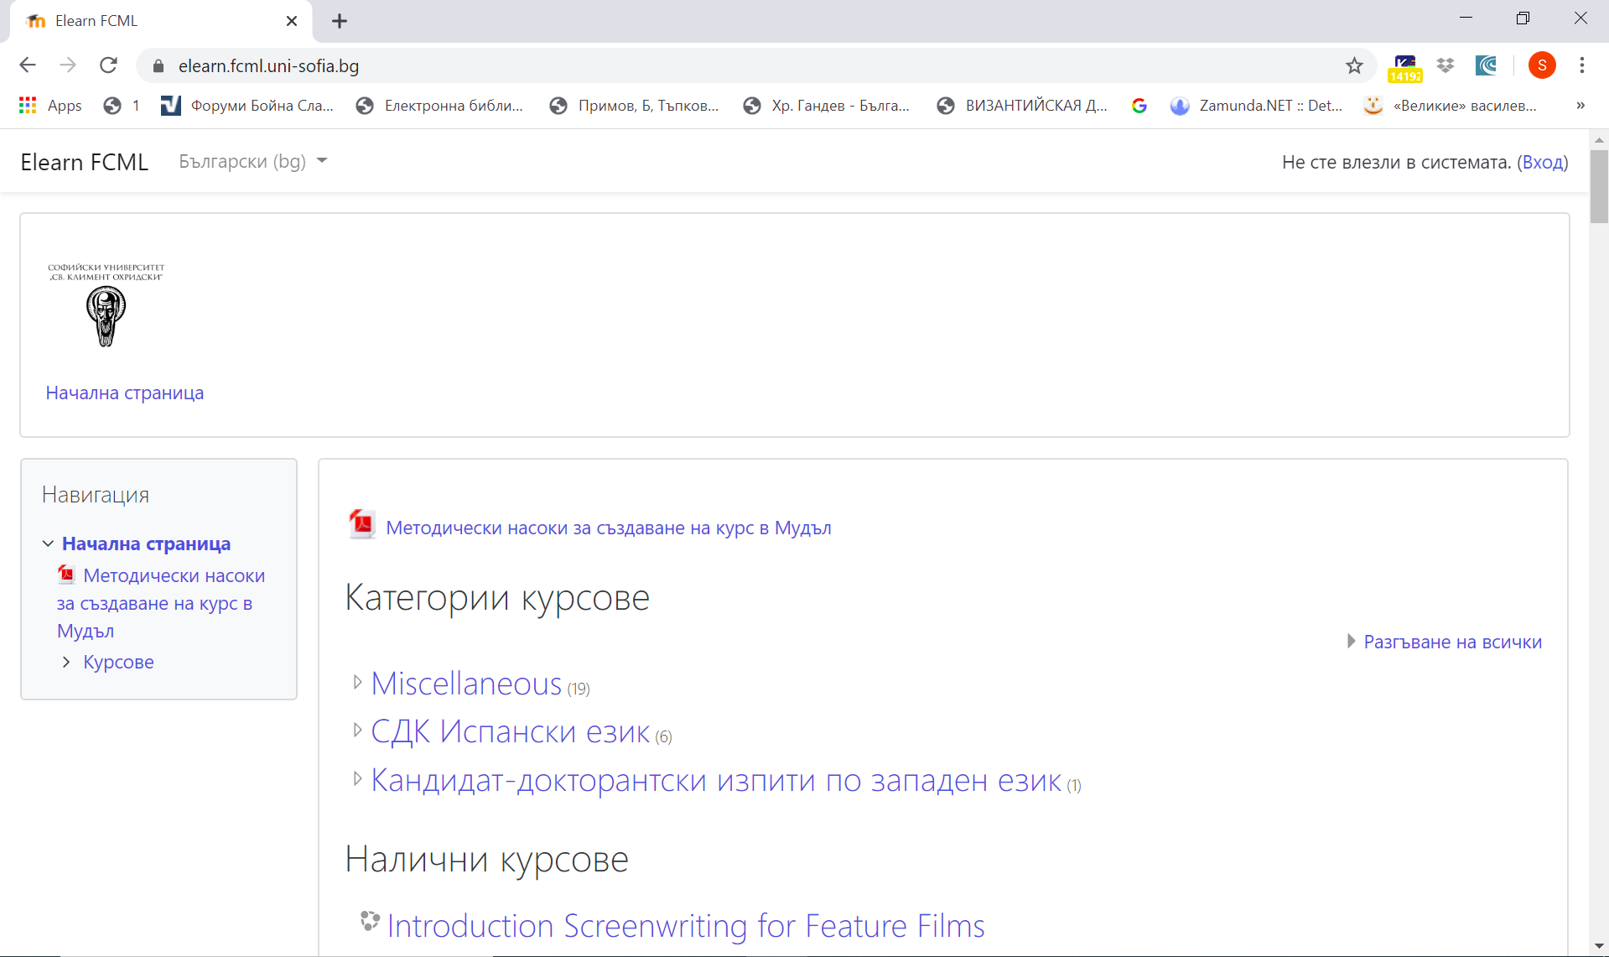

Ph.D. candidates enter the system with the received user name from the "Login" menu located in the upper-right corner of the screen.
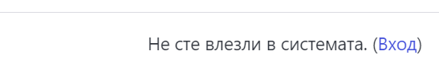
In the two fields that will appear, they fill in the received user name and password:
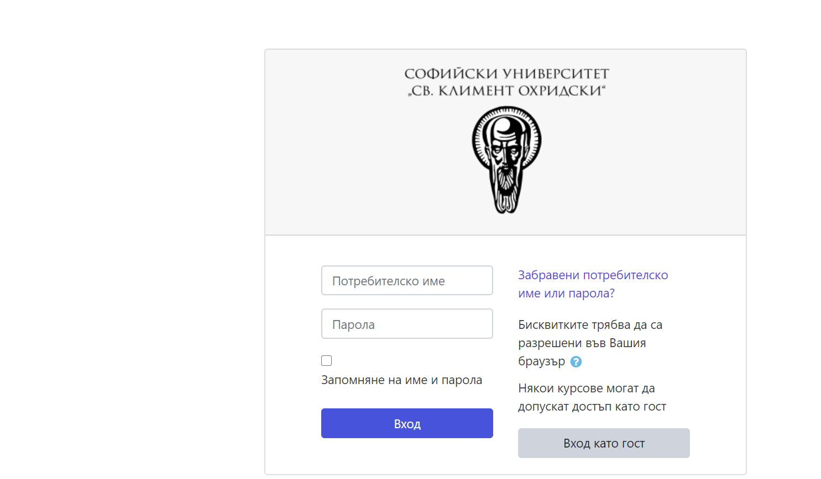

Ii. ACCESS TO THE EXAM JURY
Upon entering the system, the relevant jury will appear on the page of each of the Ph.D. candidates:
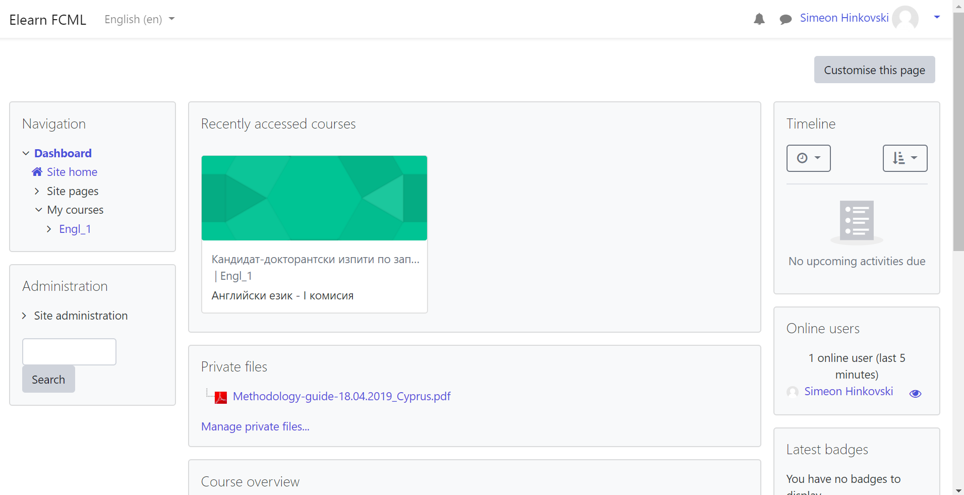

The candidate shall select the jury and enter the course. After entering the course, candidates select the “Join session” menu and follow the instructions of the jury:

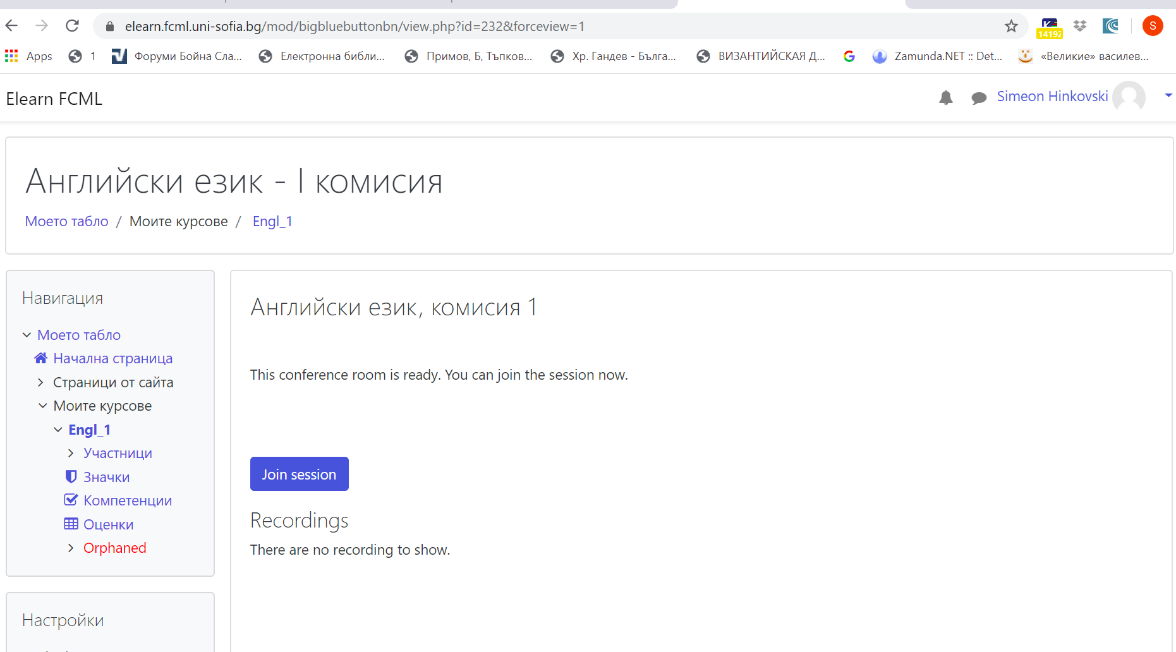

Iii. REQUIREMENTS:
Ph.D. candidates have to provide a scientific text of up to 100 printed pages of a publication in the field of the candidate's Ph.D. If the publication is in electronic format (pdf, epub, etc.), the applicants are kindly asked to send the text, they have chosen, in advance. If candidates use a printed publication, the committee will select an excerpt from the text on the spot. Ph.D. candidates have to be able to read and translate the selected part of the text and answer questions related to the grammar and vocabulary in the excerpt.

By 18 December 2021, applicants will receive a second email with a time schedule and the number of the jury to sit before.

Should any problems occur with the system and the password generation, please, contact Sr. Asst. Simeon Hinkovski, Ph.D., e-mail: hinkovski@uni-sofia.bg.

