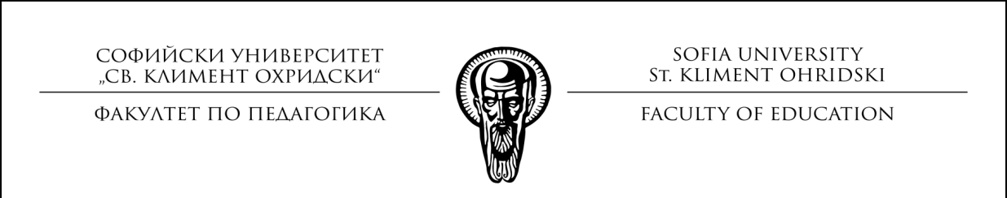
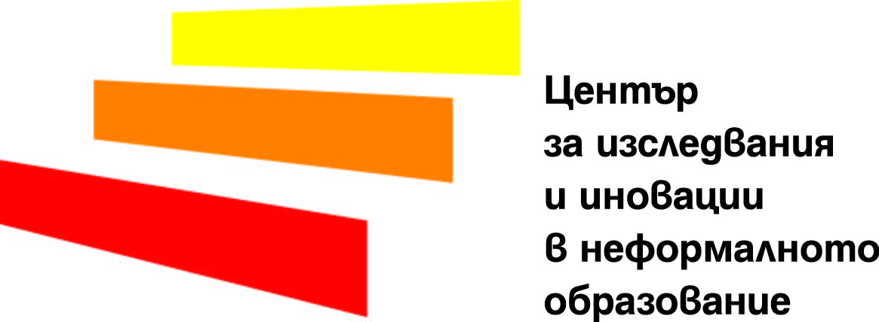

SOFIA UNIVERSITY “ST. KLIMENT OHRIDSKI” - FACULTY OF EDUCATION

CENTER FOR INTERDISCIPLINARY RESEARCH AND INNOVATION IN NON-FORMAL EDUCATION

INVITATION

INTERNATIONAL CONFERENCE:
"NON-FORMAL EDUCATION - MEETING
THE CHALLENGES OF 21st CENTURY"

4 - 6 November 2018, Sofia,
Bulgaria

Keynote speakers:

Prof. Alan Rogers (UK)

Prof. Michael Osborne (UK)

Prof. Rene Clarijs (The Netherlands)

Prof. Silvia Nikolaeva (Bulgaria)

Program at a glance:

4/11/2018 - Preliminary Program (Earth and Man Museum)

Opening /thematic seminars/ participation in the exhibition "Non-formal education"

5/11/2018 - Plenary Sessions (Assembly hall - Sofia University, The Building of Rectorate)

Plenary presentations / Promotion of "Anthology Non-formal education" / reception

6/11/2018 - Mobile visits (Sofia city thematic tours)

Study visits for acquaintance with good practices

Thematic Roundtables (Earth and People Museum)

Closure

Working language: English & Bulgarian

Website: https://ciinobg.wixsite.com/nfeconference

The conference is organized with the partial financial support of the University Research Fund - Sofia University
Suggested topic areas:

Concepts of non-formal learning and education
History of non-formal learning and education
Andragogy
Social pedagogy
Museum pedagogy
Alternative pedagogies
Models and methods of non-formal learning and education
Practical fields of non-formal learning and education
Inclusive education
Adult education
Education for sustainable development
Interdisciplinary research and innovation in non-formal education
Para-formal education
Community education
Out-of-school activities
Socio-cultural animation
Safe online-based learning and education
Corporate social responsibility and staff development
European policies and programs supporting non-formal education
​

Types of Participants and Fees

 | Standard  (3 days) | Reduced  (2 days) | Guest  (1 day) | PhD &youth  under 30  (3 days) | Payment  deadlines
Participant codes | S | R | G | D
Early bird registration fee | EUR 150 | EUR 100 | EUR 50 | EUR 80 | 31 August 2018
Late registration fee | EUR 220 | EUR 150 | EUR 80 | EUR 120 | 31 Sept. 2018

 | Participant codes:
Registration fee covers: | S | D | R | G
Participation in all conference sessions, visits, coffee breaks
2-day attendance + certificate
1-day attendance _{+ certificate}
Paper copy of the conference program
Conference materials (file, paper, pen, badge, certificate)
A .pdf copy of the conference book
Free entrance to Non-formal education exposition
A .pdf copy of the Anthology “ Non-formal education”
Conference interpreting equipment rental during plenary sessions
Paper / Poster presentation during conference

Important deadlines

31 August 2018 Standard registration (incl. abstracts)
31 August 2018 Early bird registration fee payment

25 September 2018 Late registration
31 September 2018 Late registration fee payment

31 September 2018 Full text papers
31 September 2018 Poster presentations

Registration fee payment options

Bank transfer to Sofia University bank account
BNB - Central office
IBAN: BG52 BNBG 9661 3100 174301
BIC: BN BG BG SD

Reason for payment:

”name, NFE conference / participant code”
(M. Ivanova / NFE conference / S)

Important notes

Conference registration confirmation
The conference registration will be confirmed upon receipt of the registration fee.

Cancellation
In case of cancellation, there will be no refund of registration fees.

Accommodation:
Upon request registered participants will receive a list of hotels near conference venues.

OUR PARTNERS

Technical requirements for the reports:
Volume: 5 to 7 pages, including abstract in English.
Page Technical Specifications: MSWord 2003/2007, A4, Portrait; Fields: left - 2.5 cm, top, bottom and right - 2.0 cm alignment: Alignment justified; without hyphenation; Recess (new line break): First Line Indent - 1.0; Intermediate spacing: Single; Font: Times New Roman; 12 p;
Arrangement of the material:
Title in Bulgarian: Bold, in uppercase, centered; Author(s): on the next line - authors' surnames and surnames, Bold, in large letters, also centered; Place of work - next line with Italic; English title and annotation in 1 blank line, up to 10 lines; Keywords appear on the next line with Italic.
Main text:
Structure of the report: introduction, main part, final part (e.g. conclusions and recommendations); bibliography (used and quoted in the text - indicated according to BDS, the citation is indicated in square brackets, and the sources used in the alphabetical order of the first author's family and the corresponding number, the sources of the Internet are in the total numbering, also alphabetically arranged and with the last date of use);
Tables, figures, charts, pictures and charts: integrated into the text and also numbered and named. They are also applied in separate files. Photos need to be in JPEG format.
Data on the author (s): At the end of the article, the three names of the author (s), position (including academic, scientific rank and grade), place of work; telephone and e-mail address.
Requirements for poster presentations:
A poster presentation is used by the authors of reports who can not take part in personally to submit their report to the session or consider that the issues in question can be presented better as posters.
In order to achieve greater clarity, it is necessary for the poster to contain three sections formed in the following sequence:
1. Research problem.
2. Illustrative material.
3. Conclusion.
In the " RESEARCH PROBLEM" it is necessary to give the main tasks that are solved in the development.
"ILLUSTRATIVE MATERIAL" includes diagrams, tables, photos, etc., which must be clearly legible, clear and comprehensible. To the left / top is the emblem and the name of the conference, the title of the report and the names of the authors and the beginning of the section " RESEARCH PROBLEM"
The "CONCLUSION" section is displayed at right / bottom.
The "TEXT PART" of the poster is written in one of the official languages ​​of the conference.
The poster report must be prepared on MS Power Point 97 or a newer version; A1. The font sizes are listed below. The poster must be converted and received by the Organizing Committee also in PDF format.
Font size:
• Conference title 36 pt / bold /
• Title of the report in the language of which the post is written 30 pt / bold /
• Report title in the other two languages ​​ 24 pt
• Authors' names, organization and country 16 pt
• Title of the three tabs 26 pt / bold /
• Poster text 22 pt
• Contact details for authors 16 pt

