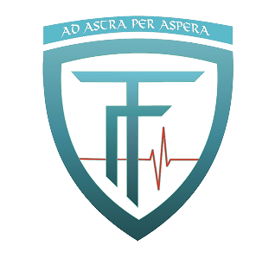
Aplication form for participation in a
Forum of students and specialists in medicine and natural sciences in Bulgaria.
"Potential of natural and synthetic factors in the fight against antibiotic resistance"
Name
Student / specialist
University
Home address
Phone
е-mail
Theme

A B S T R A C T

24-25 September, Shumen
Speech Duration: 15 minutes
Application deadline: 14.07.2022.
Abstract is to be in Bulgarian or English language
Paper work presentation eligible in Bulgarian or English.

Contact addresses for application sending:
Mihaela Toncheva, coordinator of the project, Phone: +359 899309501
Pliska, 9200, str. Dr. Petar Beron №2, e-mail: conference_fgt@abv.bg / found.gt@gmail.com

INSTRUCTION FOR WRITING:
Text of most 10 pages (space 1,5) or total 18 000 characters, i.e. 12 pages with illustrations. Abstract of most 2 pages ( to 3 500 characters). Тext must be in Word.doc. или Word.docx in Times New Roman, font size 12. Pictures in tif form of minimum 300 pixels per picture. Participant are required to furnish the organizers with their respective papers along with complete scientific references by 15 December 2022. All European languages are equal for paper works writting.

