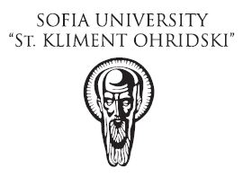 APPLICATION FORM

Please fill in the application form and send it by e-mail, not later than 10th November 2017, to both e-mails:

Atanas Georgiev - ageorgiev@feb.uni-sofia.bg

Emanuil Kozhuharov - emanuil.kozhuharov@external.total.com

The course is for students and public officials and will be in English.

Name of the course dates place

Oil & Gas Exploration & Production Contracts | 20 - 24 November 2017 | Sofia University

- Contact details of the aplicant
First Name:
Last Name:
Address: street, number, floor, apartment, city
Email address:
Cell and fixed telephone numbers:
Date of birth:

- Actual status (i.e. student, public official or other; university, employer or last employer if currently unemployed)
 | Student | Name of the University | Year and subject
 | Public official | Name of the organisation | Position title
 | Other | Name of the company | Position title
(*Inscription for the course is according to availability and validation from organizer of the course)

- Proficiency in English (indicate your level of English – basic, good, fluent)

For additional information:
Sofia University – Contact person: Assoc. Prof. Dr. Atanas Georgiev - ageorgiev@feb.uni-sofia.bg
Total E&P Bulgaria B.V. - Contact person: Dr. Emanuil Kozhuharov - emanuil.kozhuharov@external.total.com

