How to get to the Tanne Hotel from Sofia airport by public transportation?

If you decide to get to Bansko by your own means, from the airport you can either take a cab (there’s a boot in the lobby) or the metro to the central bus station. Sofia Metro Line 1 connects Sofia Airport to the city centre. The journey time from Sofia Airport to the city centre is approximately 18 min.
Changing trains from Line 1 to Line 2 at Serdika Metro Station, you can travel from the airport to Sofia Central Bus and Railway Stations within less than half an hour. The central bus station is located next to the right of the central railways station.
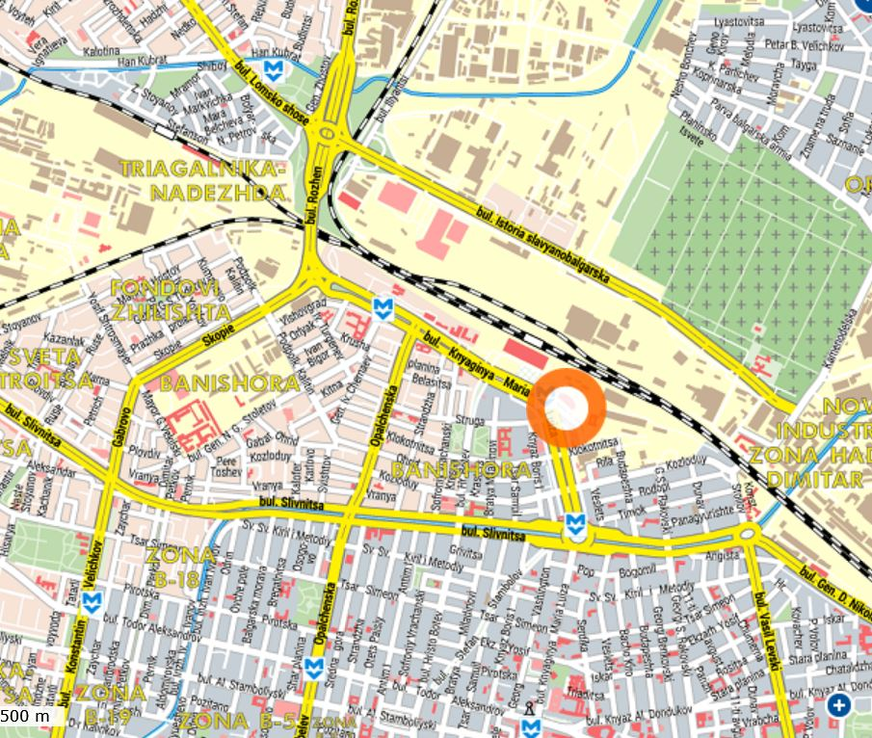
From the central bus station you can take one of the many buses which daily travel to Bansko between 6:57 am and 4:45 pm. Then you should call Mrs Popova (+359887699670) to arrange a pick-up for you, since the hotel is far from the bus station and taxis a rarity in Bansko.

