INSTRUCTIONS FOR CONDUCTING THE COMPETITIVE EXAM IN A WESTERN LANGUAGE FOR PH.D. STUDENTS – DECEMBER 2023
The Western language minimum in December 2023 will be conducted online in an electronic system, where each of the PhD students will use their SUSI account provided by their faculty. Using your account you enter the system according to a certain schedule and find the relevant exam jury, published in the electronic course of the exam. This information has also been sent to you as a message in your profile.
I. ACCESS TO THE ELECTRONIC SYSTEM
The electronic system is located at:
https://sdk.uni-sofia.bg/course/view.php?id=735
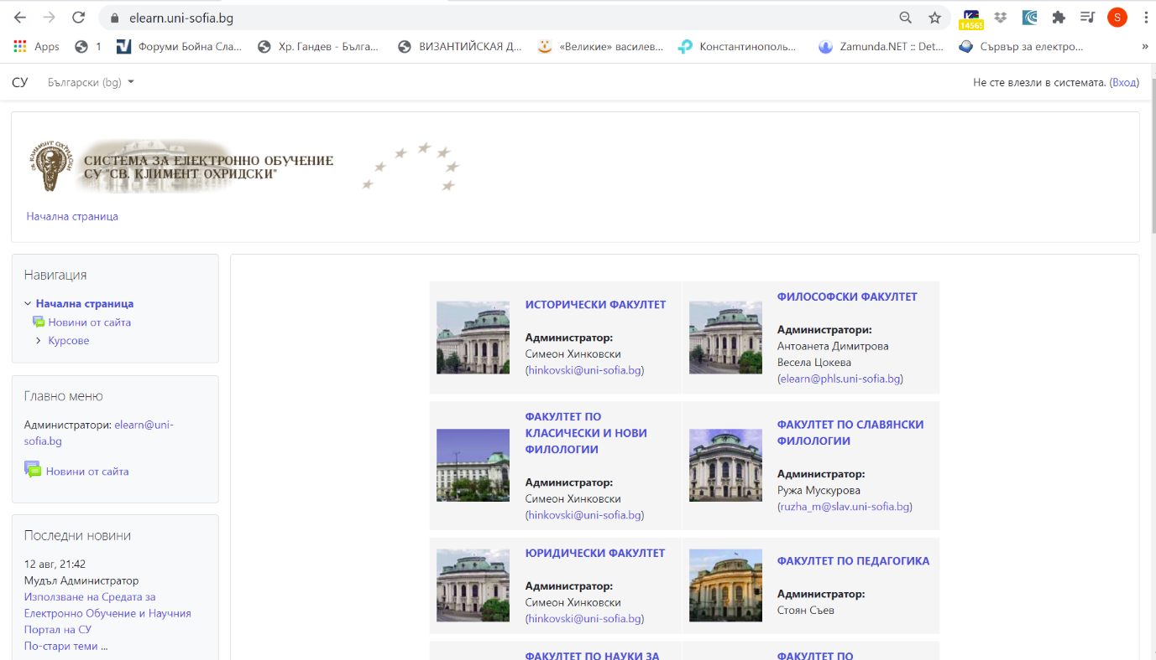

Ph.D. students enter the system with the user name from the "Login" menu located in the upper-right corner of the screen.
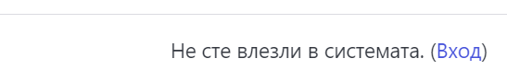
In the two fields that will appear, please, fill in the user name and password:
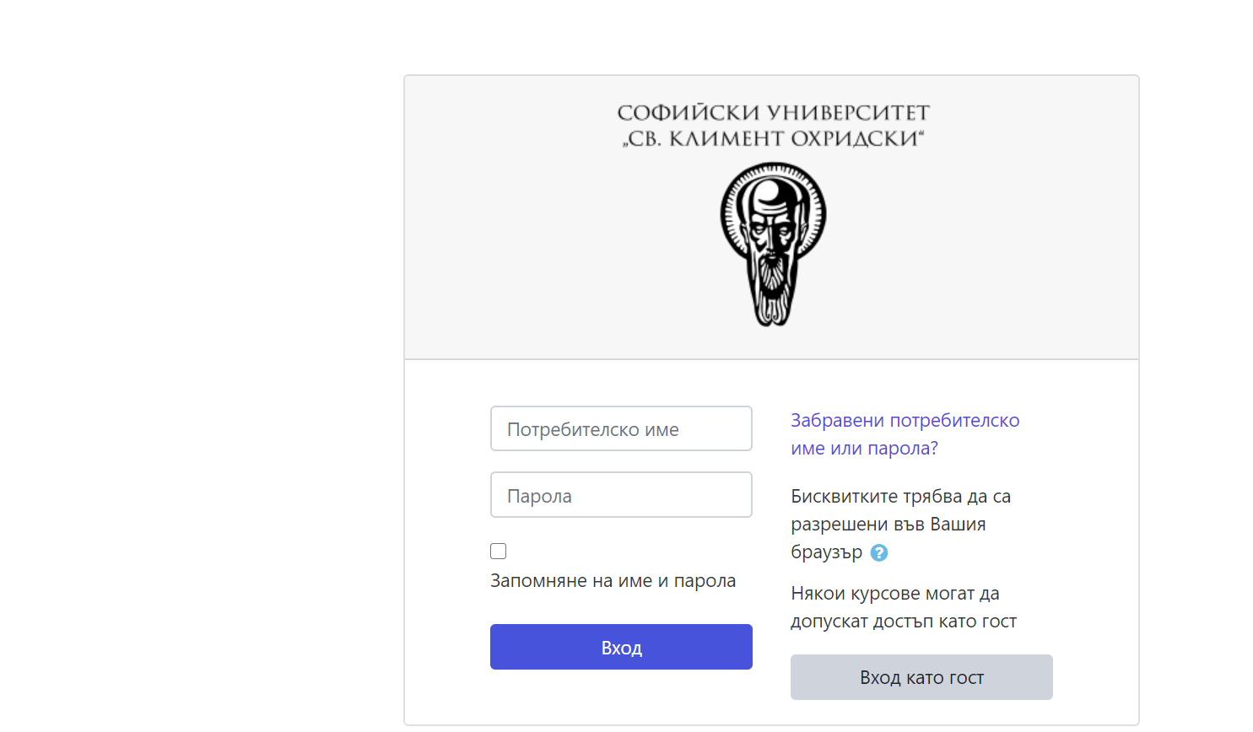

Ii. ACCESS TO THE EXAM JURY
Upon entering the system, in the section "My courses" the relevant jury will appear on the page of each of the Ph.D. students:
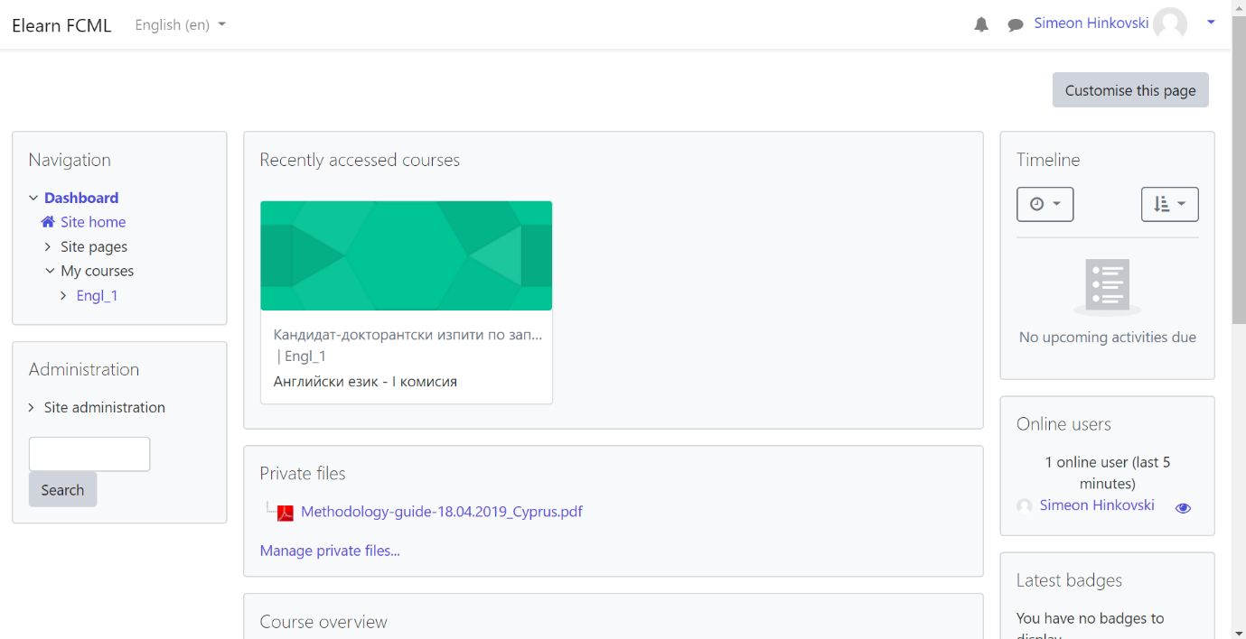

The doctoral student shall select the jury and enter the course. Then, please, select the Blue Button with your name and hour for exam, and in new window click on “Join session” button and follow the instructions of the jury:

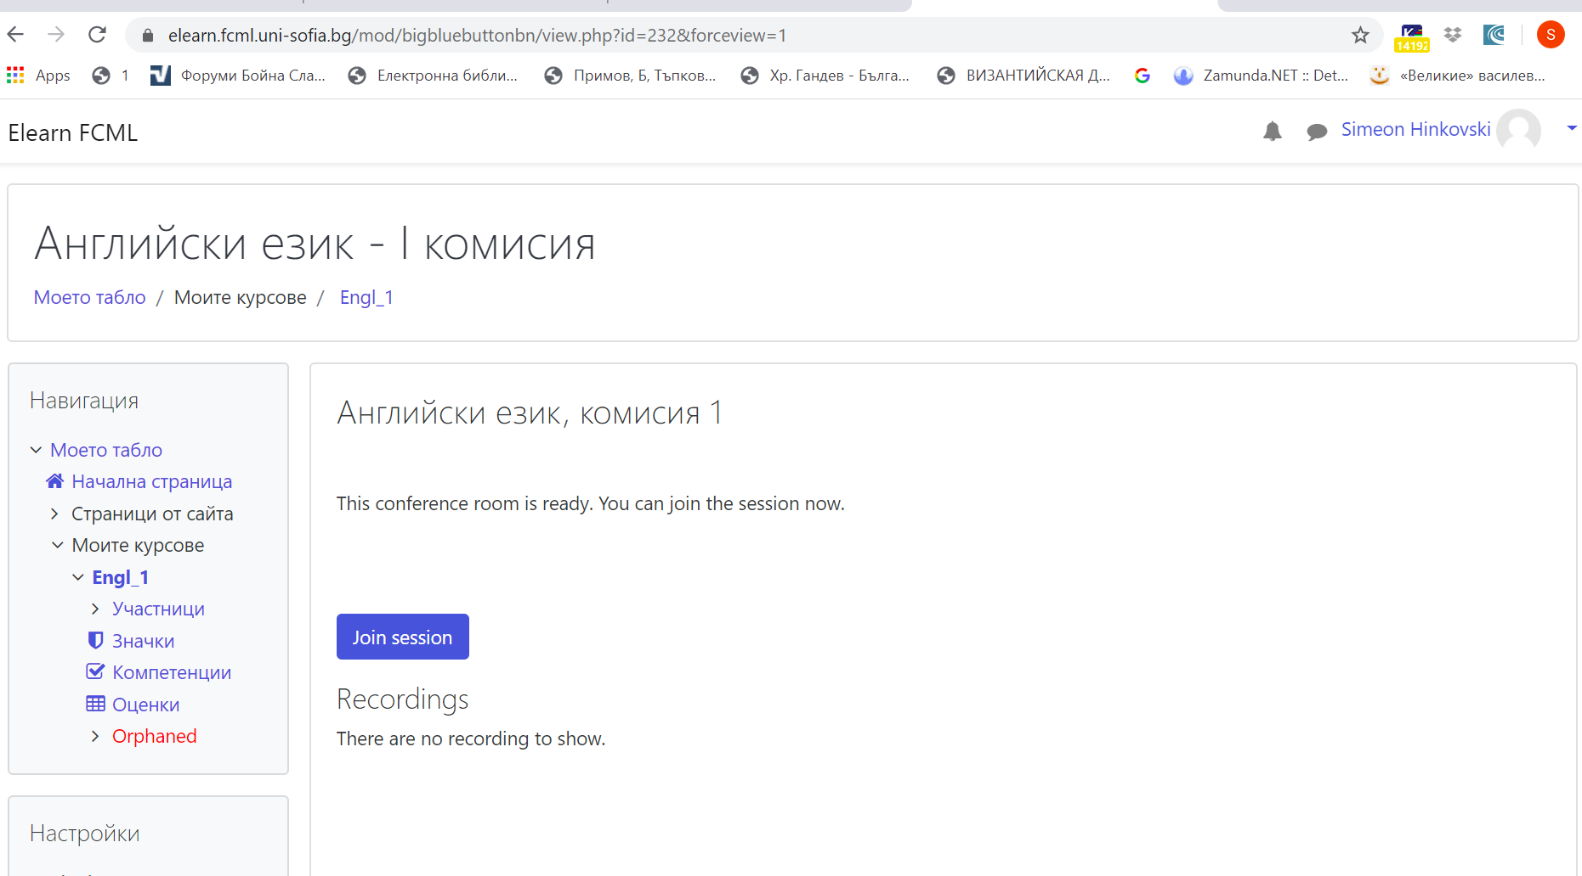
The PhD. student must enter by pressing on the microphone (upon initial entry, the browser will ask you to allow the microphone, so allow it) and after passing an echo test, press on the green thumb to contact the commission:
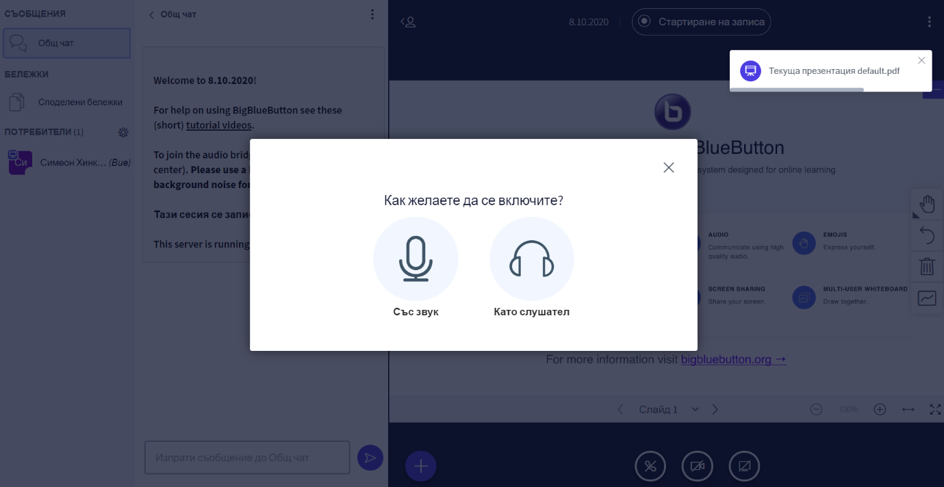
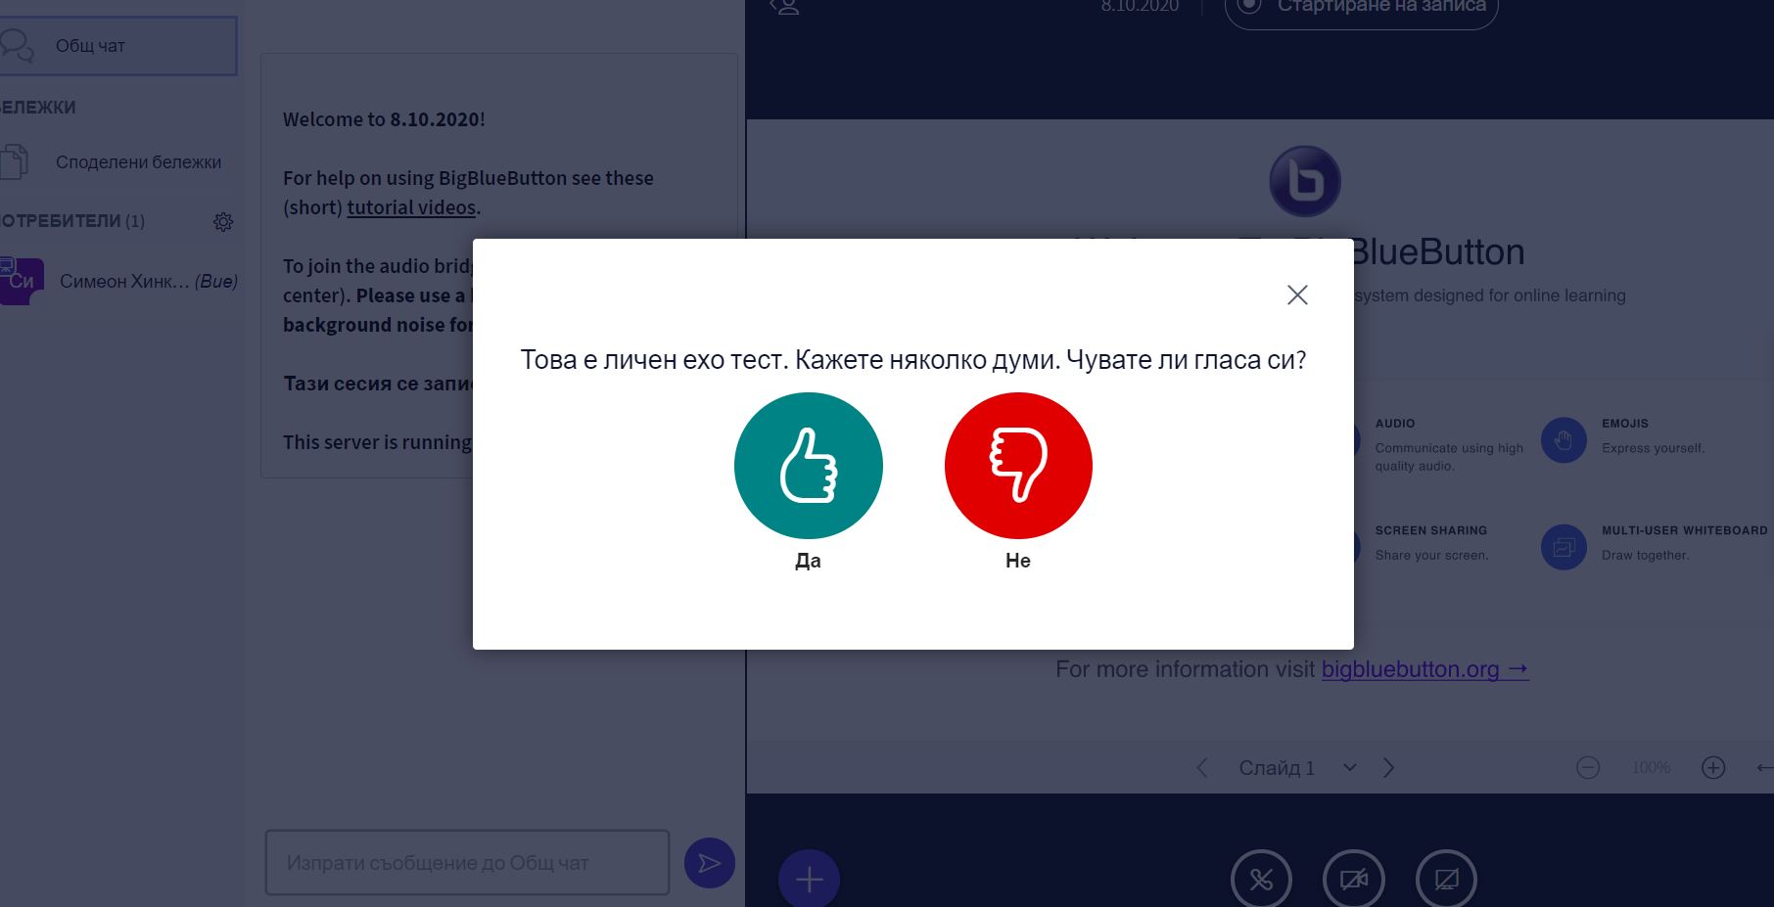

Iii. REQUIREMENTS:
Ph.D. students have to provide a scientific text of up to 150 printed pages of a publication in the field of the student's Ph.D. If the publication is in electronic format (pdf, epub, etc.), the applicants are kindly asked to send the text, they have chosen, in advance. If students use a printed publication, the committee will select an excerpt from the text on the spot. Ph.D. students have to be able to read and translate (or summarize) the selected part of the text and answer questions related to the grammar and vocabulary in the excerpt.

ATTENTION: Each of the doctoral students has to contact the faculty officer in good time before the exam and make sure that their profile works. In certain cases, you will need to enter an active email in which you will receive a link to confirm your account. Only then will you be admitted to the courses. You should complete this procedure not later than 2 hours before the exam in order not to disrupt the established schedule of the exam jury !!!
Should any problems regarding entering the system occur, please, contact Sr. Asst. Simeon Hinkovski, Ph.D., e-mail: hinkovski@uni-sofia.bg, or in phone +359 878-79-26-47.

