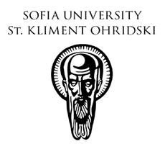
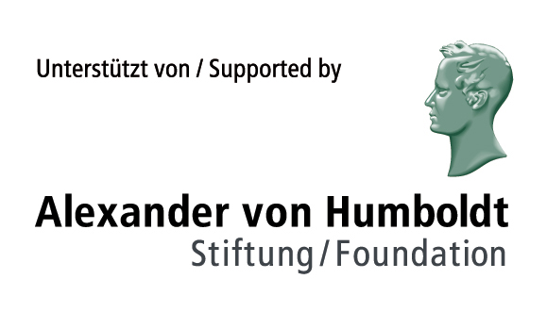

Program of the Humboldt Conference
New Realism / Der Neue Realismus

FRIDAY
26.05.2017
Location: Sofia University (Main Building)
Aula Magna
11.00 – 11.30 | Official opening of the conference  Maria Stoycheva, Vice-rector  of Sofia University St. Kliment Ohridski  Maurizio Ferraris, President of the Laboratory for Ontology  at the University of Turin  Alexander Kanev, Chair of the Department  of the History of Philosophy  Other officials & Congratulatory addresses
11.30 – 12.30 | Maurizio Ferraris (Turin): Learning From Post-Truth
12.30 – 14.00 | Lunch
FRIDAY
26.05.2017
Location: Sofia University (Main Building)
New Conference Hall
14.00 – 14.45 | Jens Rometsch (University of Bonn)  What’s a Realist Concept of Reality?
14.45 – 15.30 | Hyun Kang Kim (University of Applied Sciences Düsseldorf)  The Real in Film
15.30 – 16.15 | Enrico Terrone (FMSH Paris, University of Turin)  Does Perception Matter? The Parallel Lives of  New Realism and Naïve Realism
16.15 – 16.45 | Coffee break
16.45 – 17.30 | Georgi Kapriev (University of Sofia)  Das Sein des Gedankens als Gedanke bei Anselm von Canterbury und die Sinnfeldontologie
17.30 –18.15 | Anton Friedrich Koch (University of Heidelberg)  Hermeneutischer Realismus und transzendentaler Idealismus
18.30 – 19.00 | Lora Tasseva  Presentation of the Programs of the Alexander von Humboldt Foundation
19.30 | Reception: Hall Alma Mater  (hosted by the Faculty of Philosophy, Sofia University)
SATURDAY
27.05.2017

Location: Sofia University (Main Building)
New Conference Hall
09.30 – 10.15 | Stilian Yotov (University of Sofia)  Der Neue Realismus und die Wiederentdeckung Schellings
10.15 – 11.00 | Luca Illetterati (University of Padua)  Constructivistic Consequences of New Realism
11.00 – 11.30 | Coffee break
11.30 – 12.30 | Markus Gabriel (University of Bonn)  Mental Realism –  New Realism’s Philosophy of Mental Appearances
12.30 – 13.15 | Christo Todorov (New Bulgarian University, Sofia)  Wozu brauchen wir den Wahrheitsbegriff?
13.15 – 14.30 | Lunch
14.30 – 15.15 | Alexander Kanev (University of Sofia)  How Is (Non-)Being Possible?  On the First Principles of Reality
15.15 – 16.00 | Tiziana Andina (University of Turin):  For a Realistic Conception of the State
16.00 – 16.30 | Coffee break
16.30 – 17.15 | Katerina Kolozova  (Institute of Social Sciences and Humanities, Skopje)  Some Political Considerations of the Inhuman  in an Automated Era
17.15 – 18.00 | Nikolai Milkov (University of Paderborn)  What Is Analytic Philosophy?
18.00 – 19.00 | Mario de Caro (University of Rome III, Tufts University)  Realism and Pluralism
19.30 | Reception: Alma Mater Hall  (hosted by the Department of the History of Philosophy)
SUNDAY
28.05.2017

Location: Sofia University (Main Building)
New Conference Hall
10.00 – 10.45 | Jan Voosholz (University of Bonn)  A Formal Ontological Game. Does Meillassoux's Speculative Realism Need a Correlation?
10.45 – 11.30 | Stanimir Panayotov (Central European University, Budapest):  Speculative Manhood  Nihilism, Eliminativism and Realism
11.30 – 12.15 | Svetlana Sabeva (University of Plovdiv)  Phänomenologie der lebendigen Erde:  Realismus ohne Naturalismus
12.15 – 13.30 | Lunch
13.30 – 13.45 | Tobias Keiling (University of Freiburg)  What Is Phenomenological Realism?
13.45 – 14.30 | Georgi Gerjikov (University of Sofia)  Fields of Sense and the Contemporary Status of the Subject
14.30 – 15.00 | Coffee break
15.00 – 15.45 | Vassil Vidinsky (University of Sofia)  The Notion of ‘Metaphysical Context’ and the New Realism
15.45 – 16.30 | Alex Kostova (University of Sofia):  Truth Without Representation: New Realist Ways of Overcoming Dogmatism
16.30 – 16.45 | Alexander Kanev (University of Sofia)  Closing Remarks
20.00 | Dinner

