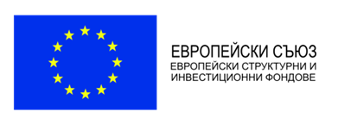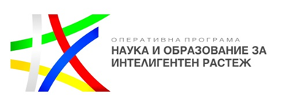

FACULTY OF MEDICINE AT SOFIA UNIVERSITY “ST. KLIMENT OHRIDSKI” announces public invitation for associated partners for a project under Operational Programme “Science and education for smart growth”

Faculty of Medicine at Sofia University “St. Kliment Ohridski” announces public invitation for associated partners for participation in activities implementation in a project under Operational Programme “Science and education for smart growth”, procedure BG05M2ОP001-1.002 Creation and development of centres of competence, Component 3 Industry for healthy living and biotechnology. The Guidelines for applicants for the grant procedurecould be found at:
http://sf.mon.bg/?go=news&p=detail&newsId=410

According to the Guidelines the “associated partners of grant applicants” are all interested party with regard to the project implementation and involved in the implementation of the project activities but which do not spend grant funding.
Eligible under the present grant procedure are legal entities supporting the project implementation which have qualification and experience in the field of innovative rahabilitation and occupational therapy methods in severe medical conditions.
Associated partners will be ineligible where they:
а) Have a member of the management or supervisory body, or a person temporarily performing such duties, including procurators or commercial agents, which are in close links within the meaning of §1 (1) of the Supplementary Regulations to the Conflict of Interest Prevention and Ascertainment Act with regard to the Head of the Managing Authority;
b) Fall in the cases referred to in Articles 21 or 22 of the Conflict of Interest Prevention and Ascertainment Act.
In regard with this, associated partners must submit a Declaration of no conflict of interest (Annex IIa to the Guidelines for Applicants), completed and signed by all persons authorised to represent the partner (irrespective of whether the type of representation is joint and/or separate and/or otherwise).
In the event of engagement of municipalities as associate partners under the procedure, a letter of support for the project implementation from the municipality on whose territory the project activities will be implemented shall be submitted.
The awarded associated partners have to sign a Declaration of partnership in accordance with the provided template (Annex IIIa to the Guidelines for Applicants) in which all collaborative activities must be specifie

Interested party – candidates for associated partners should fill in the following data:

Interested party – a candidate for associated partner
Name
Legal status
National registration number
Headquarters
Address for correspondence
Main activity of the organization
Short description of the qualification and experience in the field of innovative rahabilitation and occupational therapy methods in severe medical conditions
Phone number
E-mail
Internet page
Authorised representatives:
- Name and position
- Name and position
- …
n. …

Together with the above information, the candidates should submit (signed and scanned) the Declaration of no conflict of interest, Annex IIa (that could be downloaded from:
http://sf.mon.bg/?go=news&p=detail&newsId=410).

The candidates should send their information and documents via e-mail and submit them to the following e-mail:
hospital.lozenets@abv.bg

The deadline for submission is 22 February 2017

