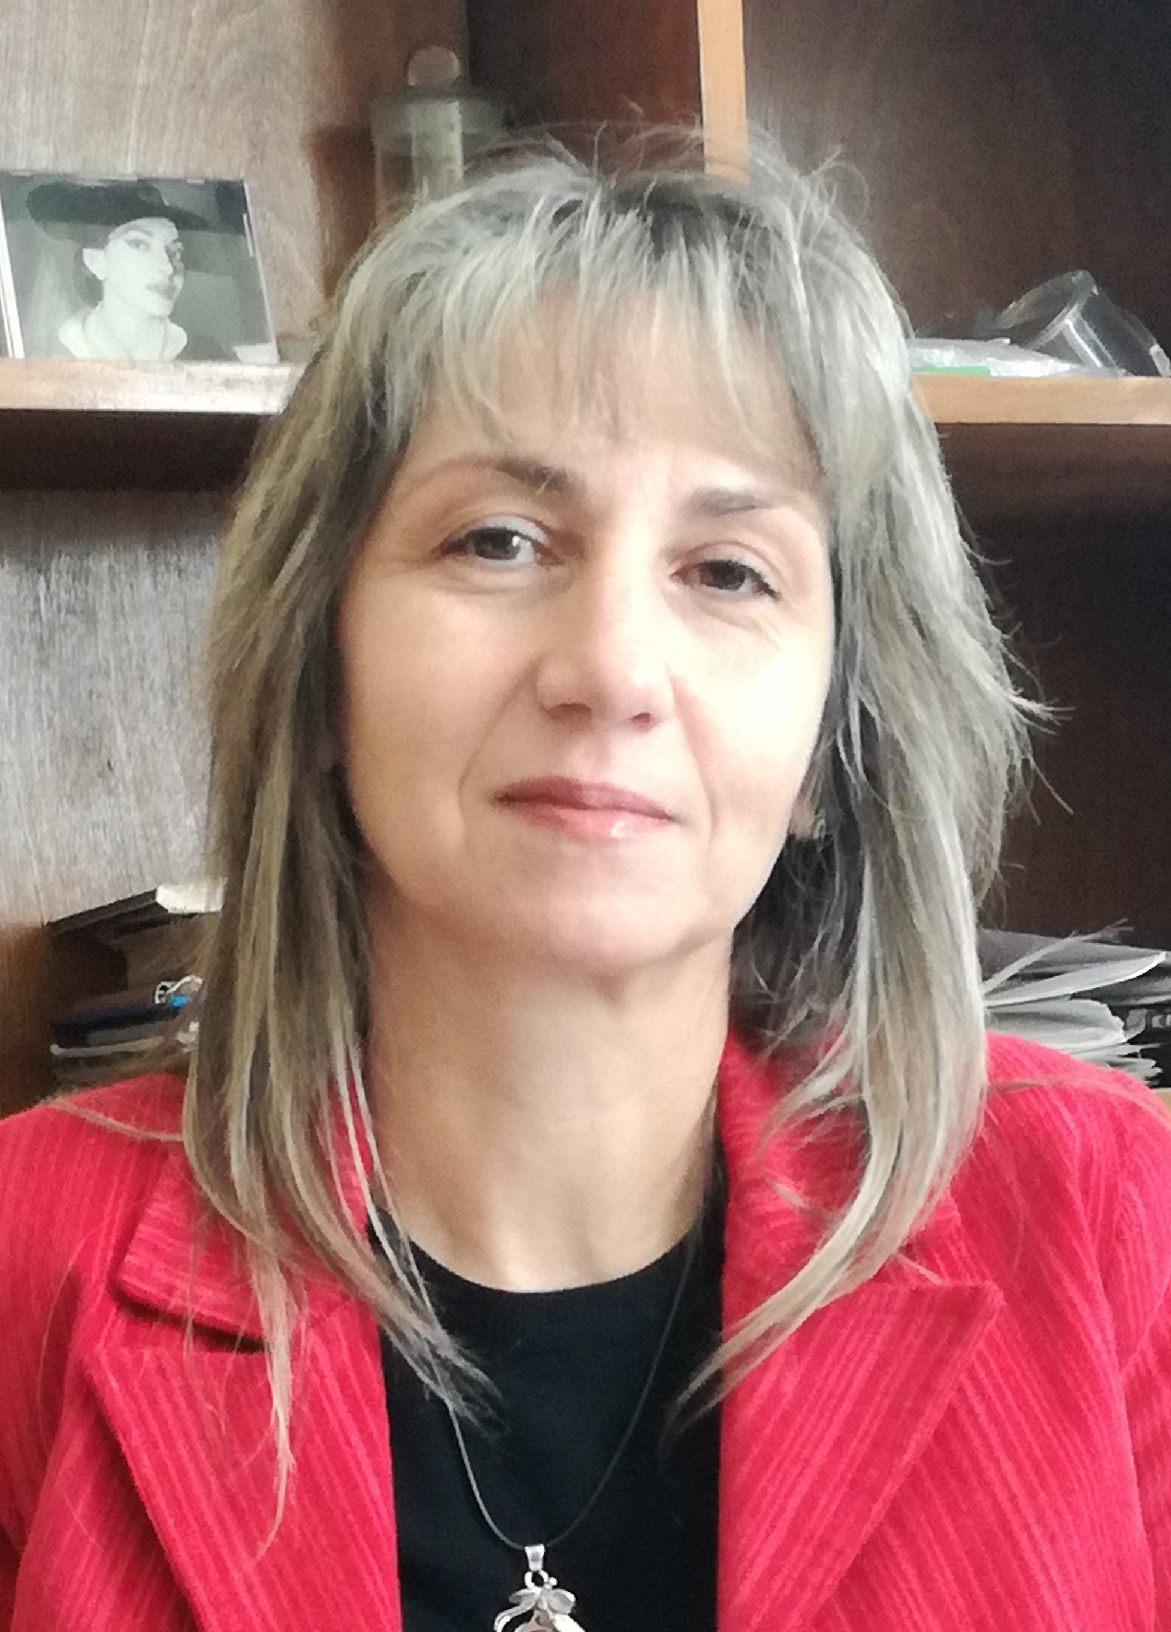Borjana V. Donkova, Ph.D.
Associate Professor in Inorganic Chemistry
Department of Inorganic Chemistry,
Faculty of Chemistry and Pharmacy
University of Sofia “St. Kliment Ohridski”
1 James Bourchier str.
1164 Sofia, Bulgaria
Phone: + 359 2 8161 214

E-mails: bdonkova@chem.uni-sofia.bg

Education:
1988 M.Sc. in Chemistry (Specialisation: Inorganic and Analytical Chemistry) Faculty of Chemistry, Sofia University “St. Kliment Ohridski”
2006 Ph.D. degree in Inorganic Chemistry
Faculty of Chemistry, Sofia University “St. Kliment Ohridski”
Topic of Ph.D. Thesis: Investigation of inclusion mechanism of 3d-elements in ZnC₂O₄.2H₂O precipitate and its application for obtaining of oxide materials.

Employment
1988–1989 Chemist-researcher at Institute of high purity substances,
Faculty of Chemistry, Sofia University “St. Kliment Ohridski”
1994–1998 Fellow Assistant Professor, Faculty of Chemistry, Sofia University
1998–2003 Assistant Professor, Faculty of Chemistry, Sofia University
2003–2006 Senior Assistant Professor, Faculty of Chemistry, Sofia University
2006–2014 Head Assistant Professor, Faculty of Chemistry, Sofia University
2014– Associate Professor in Inorganic Chemistry, Faculty of Chemistry and Pharmacy, Sofia University
2019– Vice-dean, Faculty of Chemistry and Pharmacy, Sofia University

Research interests:
Crystallization and cocrystallyzation processes at moderately and sparingly soluble compounds; Thermal decomposition; Catalysis and photocatalysis; Nanoscale materials and composites.

Publications:
ORCID: 0000-0001-7414-390X
Scopus Author ID: 8659306100
Web of Science ResearcherID: AAM-3448-2021

Teaching activities (lectures):
core B.Sc. courses: High-purity substances , General Chemistry, Chemistry of Elements,
Advanced Chemistry, General and Iinorganic Chemistry –I part and II part.
core M.Sc. courses: Methods for preparation and purification of Inorganic substances (in Master’s program Inorganic and hybrid materials for advanced technologies); Introduction to university chemistry (in Master’s program Cosmetics and household chemistry).

Councils and panels:
2008 - Faculty Council of the Faculty of Chemistry and Pharmacy
2011-2019 Didactic Commission of the Faculty of Chemistry and Pharmacy
2019 - Expert for the National Evaluation and Accreditation Agency

Membership
Union of the Bulgarian Chemists

